TASK:

DCCN LAB 14

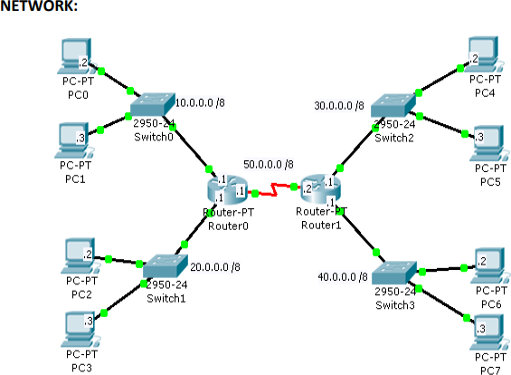

1. Configure the network as shown in above figure
2. Use RIP to enable dynamic routing

IMPLEMENTATION:

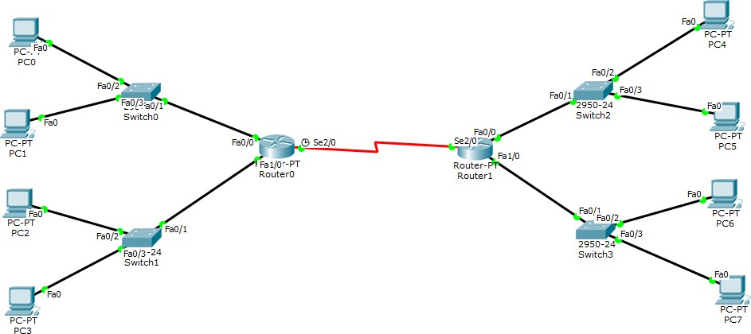

ROUTER0 CLI:

BASIC CONFIGURATION:

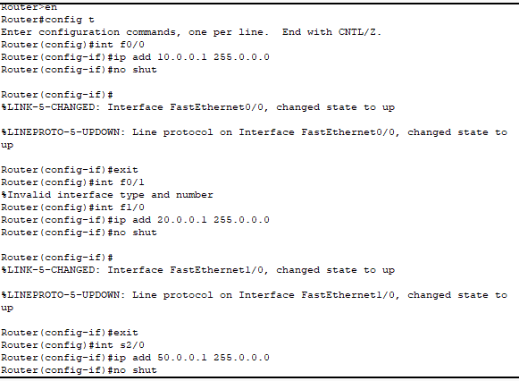

RIP CONFIGURATION:

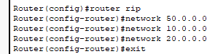

ROUTER1 CLI:

BASIC CONFIGURATION:

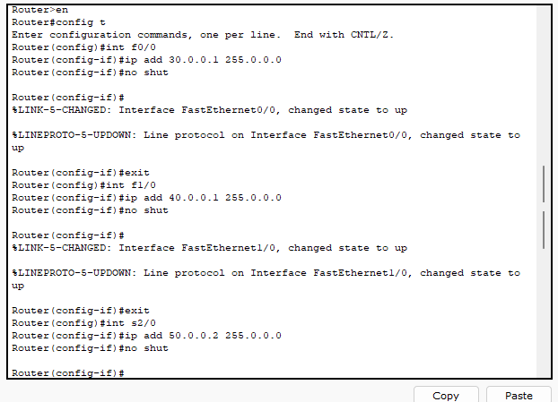

RIP CONFIGURATION:

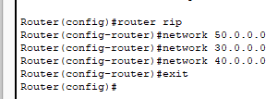

PACKET TRANSFERRED SUCCESSFULLY:

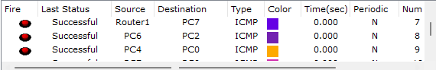

TASK # 1:

To deny the traffic from 40.0.0.2 /8 from entering into 20.0.0.0 /8 network Configuration on Router0.

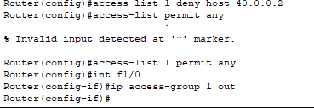

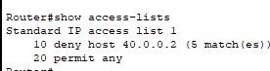

PACKET DOES NOT TRANSFER:

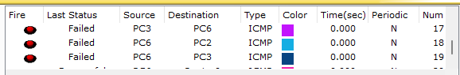

TASK # 2:

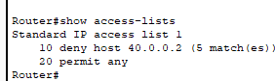

**TASK # 3:** To remove the ACL from the router and interface

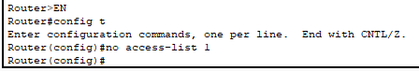

TASK 2:

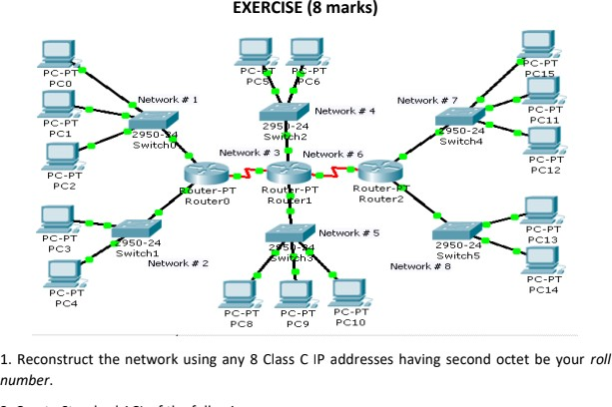

OUTPUT:

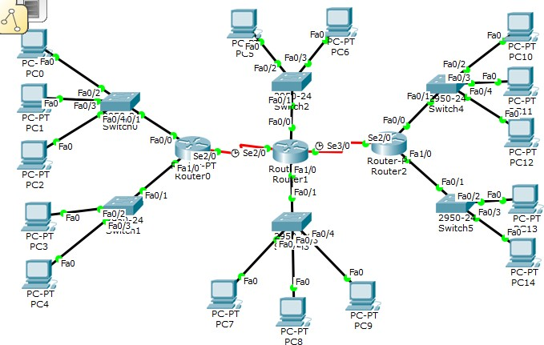

ROUTER0 CLI:

BASIC CONFIGURATION:

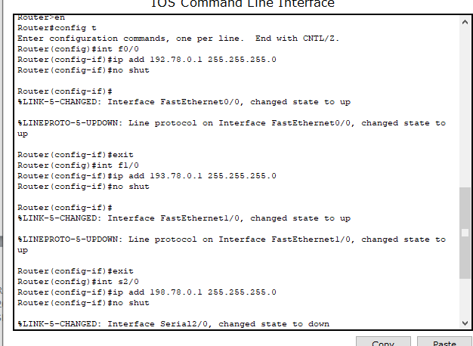

RIP CONFIGURATION:

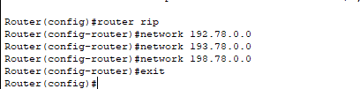

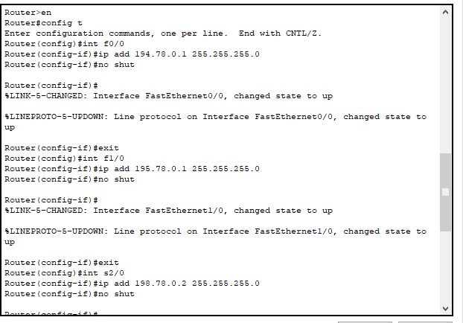

RIP CONFIGURATION:

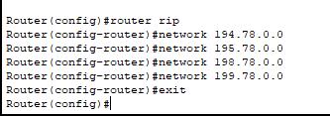

ROUTER2 CLI:

BASIC CONFIGURATION:

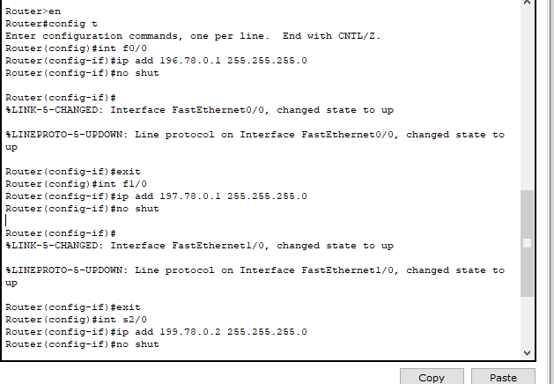

RIP CONFIGURATION:

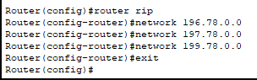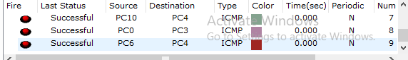

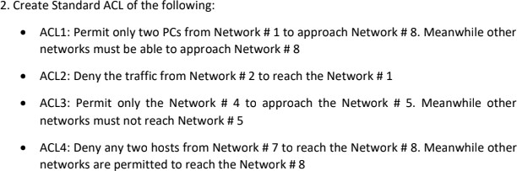

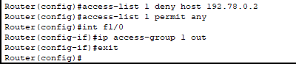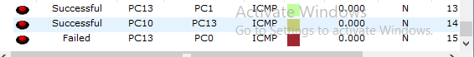

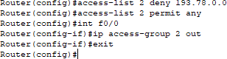

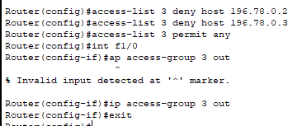

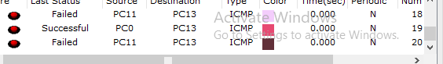



BECAUSE, STATEMENTS ARE RUN SEQUENTIALLY.